**X.8. Sale**

Since we want Moogle to incorporate bidding and the sale of items we need to be able to adjust the database to account for two different types of buying an item on the site. This an important aspect of the business since some customers may not like bidding for items or do not want to wait for the time to be up on the bidding to get the item. Having items just for sale will help bring in those other customers that want to just buy out the item right then and there for a reasonable price. Implementation for this feature will not be hard to incorporate with the bidding system so it will be in the company’s best interest to add this feature to items. Since users will have credit cards in our system it will be easy for them to click buy items right away raising the amount of items sold. Also items can be posted by suppliers for either sale or bidding at the discretion of the suppliers and will give them a chance to post their items so that they are sure they will get the money they want for an item. Instead of possibly selling the item at a lower price than they were hoping for through bidding. This will also encourage suppliers to post more items than if we just incorporated bidding in the business.

With respect to the database model the sale of an item will be incorporated in the item entity as described in section X.1. If the item is for sale and not bidding then the information will be null in the bidding attributes and the sale attribute will have the information needed such as the price. If the item is for bidding then the opposite will happen where the sale attributes will be null. This will also require a user to have a credit card on file so if there is no credit card or no valid credit card then the user will be forced to add one to their profile. Since we will want to keep the history of the sale items for at least 6 months after the sale we can set up a relationship between Registered User and Sale Item as shown below. The SaleID will be there so that even if the user or the item leaves our database there will still be record of the relationship and record of the sale.

[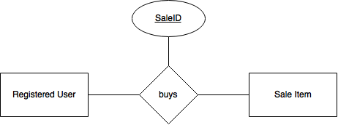](https://cloud.githubusercontent.com/assets/5253312/12772117/7b14a626-c9fc-11e5-9e91-0f409571b77e.png)